Dryer Process Control and Techniques

Process Instrumentation – Home Assignment – Blog

Vivek Chandrashekhar Rugale – C24 – 11810369

Drying is one of the very important process used in the wide range of industries like food, pharmaceutical, pulp and paper, textile, agriculture, biotechnology, mineral, polymer, etc. The purpose of drying is to reduce the moisture content in the product to a desired level. Conditions like under drying or over drying can affect the quality of the product very badly hence, a proper control system is very important for dryers. Drying is highly energy demanding procedure. It represents approximately 20% of industrial energy. These industrial dryers operate at very low efficiency from 10% to 60%, which then increases the cost of the operation. These performances have to be improved and this can be done using the control tools. Control techniques are extensively used in chemical industries since the mid-1970. There are various types of dryers used in industries depending upon the application and no single controller can be applied to all dryers. Research in these drying controllers in mainly focused on the understanding drying mechanism and quality of output product rather than control of operation. In case of dryers, major cost is involved in daily operation than initial investment. Use of control system provides energy and cost efficient operation with desired product quality. Many applications of drying has resulted in a drastic decrease in cost and energy and increase in production due to dryer control systems.

While designing a dryer for a particular application, the type of actuators, sensors, dryer type, dimensions have to be considered and these variables are called design variables. After building of dryer, the manipulated variables like product humidity, airflow rate, heating power, temperature etc. come into picture. These all variables are crucial in designing a control system. Tuning of manipulated variables is the primary concern in control. The objective of the control system is to reduce the rise time, overshoots and steady state error and make the system robust with good disturbance rejection. Manipulated variables can be tuned in two ways –

* Offline Control – It is an open loop control. If the operating conditions, process behavior and required product specifications are accurately known then the variables can be tuned before the drying process and used during the process.
* Online Control – Except the product specifications, the operating conditions and feed characteristics are not constant in reality and they affect the process badly. So in real time, the effective way to tune the manipulated variables is during the process which is closed loop control.

In online control, the variables can be tuned manually or automatically. In manual control, the operator observes the process and adjusts the manipulated variables. This is very simple but it causes lag in decisions due to disturbances and decreases the system performance when system is complex. Automatic control uses smart and intelligent controllers like PID, which continuously measures the control variables and disturbances and improves the performance of the process by taking decisions at every time instants. Automatic control has ability to handle very complex processes. In automatic control of process a model is required for tuning of the controller which can prepared as follows –

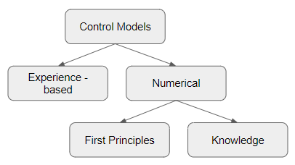

Experience based model is developed by the operator in manual control through the years of experience which takes time to get built and depends upon the operator. Numerical models are most used due to the development of computers over past decades. These models are used to control complex processes automatically. First principle based models, which are based on the mass, heat, and momentum balances are described by the static/dynamic or partial differential equations or linear/non-linear equations. The parameters in this model has some physical significance. On the other hand, the neural network model, fuzzy model or genetic algorithm models are the knowledge based models. Several process data is required to design this model. Parameters in this model has less physical significance and validity outside the dataset is not known.

A proper control strategy has to be selected based on the type of dryer, application and control problems. There is no universal control technique exist for any application. Following diagram shows the control strategies used in drying technology-

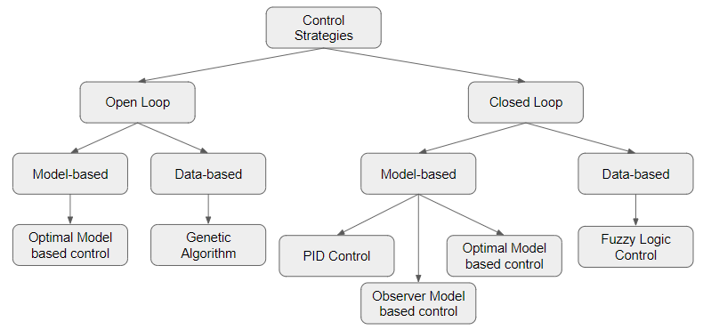

Open loop control is already discussed above. Optimal control is a control strategy that minimizes the certain cost of operation. This is plainly the best approach in drying if the operating conditions and process characteristics are accurately know in advance, which is not the case in reality. Genetic algorithm (GA) is another control strategy in open loop control, which is based on the process data. GA is an emerging field in control engineering, which is motivated from the biology of evolution and concepts like mutation, natural selection, inheritance, etc. GA can applied if the proper process knowledge is already known. Its drawback is the computational time, which could extend for days.

Moving on further, comes closed loop control techniques, which are more reliable and highly efficient control strategies in industrial drying. Mathematical model based controller like PID is a very powerful tool in control. PID control was founded in 1942. Since then it got much attention in control engineering as it gives desired output with very small investment. Today, PID is used in almost 90% control applications in industry and it is very efficient in drying. PID controller tracks the controlled variable as close as possible to the set point. Observer based control strategy is a very effective tool in non-linear control theory. The main purpose of observer-based control is to design a model based soft sensor, which is the observer. Optimal model based control theory is about control techniques that can be constructed using the optimization algorithms. Optimal control is involved in finding a control policy for given process such that certain optimality standard is attained. A specific class of optimal control is the predictive control. Model-based predictive control includes solving optimization problems expressed into the future. This control predicts the future behavior of the process and accordingly manipulated variables are tuned. This control is used widely in chemical and petrochemical industries. For the data based control of dryers, the data is fed to the computer and the computer makes the inferences from on-line measures and can draw conclusions. Computers can give the advice for tuning of manipulated variables. It can solve various problems which may not be dealt with other traditional methods. The fuzzy logic control is also dependent on the large process data. It reduces the time for engineering development. Fuzzy logic is used in system control because it can solve very complex problems and it may be the only way of solving those problems. All these above control schemes can be used with the feedback control or feedforward control. Feedback control measures the control variable and then through the controller adjusts the manipulated variable while on the other hand feedforward control measures the disturbances and based on that take corrective action before those disturbances affect the system. These feedback and feedforward controls can be used combined or cascaded.

Control in drying process is now implemented in most of its applications. Around 66% of drying control applications are related with the food. This is because drying process decides the quality of the food products. Other evolving fields in drying process control are pharmaceuticals, painting, wood and paper industries. A proper controlled and accurate drying process increases the quality and life of product and so as the production. The 75-year-old PID is still the major control tool in most of the industries due to its easy implementation and tuning. Model-based control algorithms are used nowadays since it represents process behaviors. Model is very helpful in implementing control strategies. For optimal drying conditions, usually the first principle model based controllers are used. More accurate models will result in more accurate control of dryers. There are around 100 different types of dryers used worldwide and thus control in drying is a high potential field. The first application of control strategies in drying processes was introduced in 1979 and since then this field has evolved greatly and will keep developing with new high-end control techniques in future.